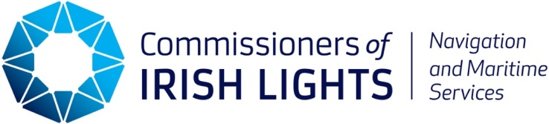

Candidate Information Booklet

SELECTION PROCESS FOR THE BOARD OF THE
COMMISSIONERS OF IRISH LIGHTS
Closing Date: 29th April 2026
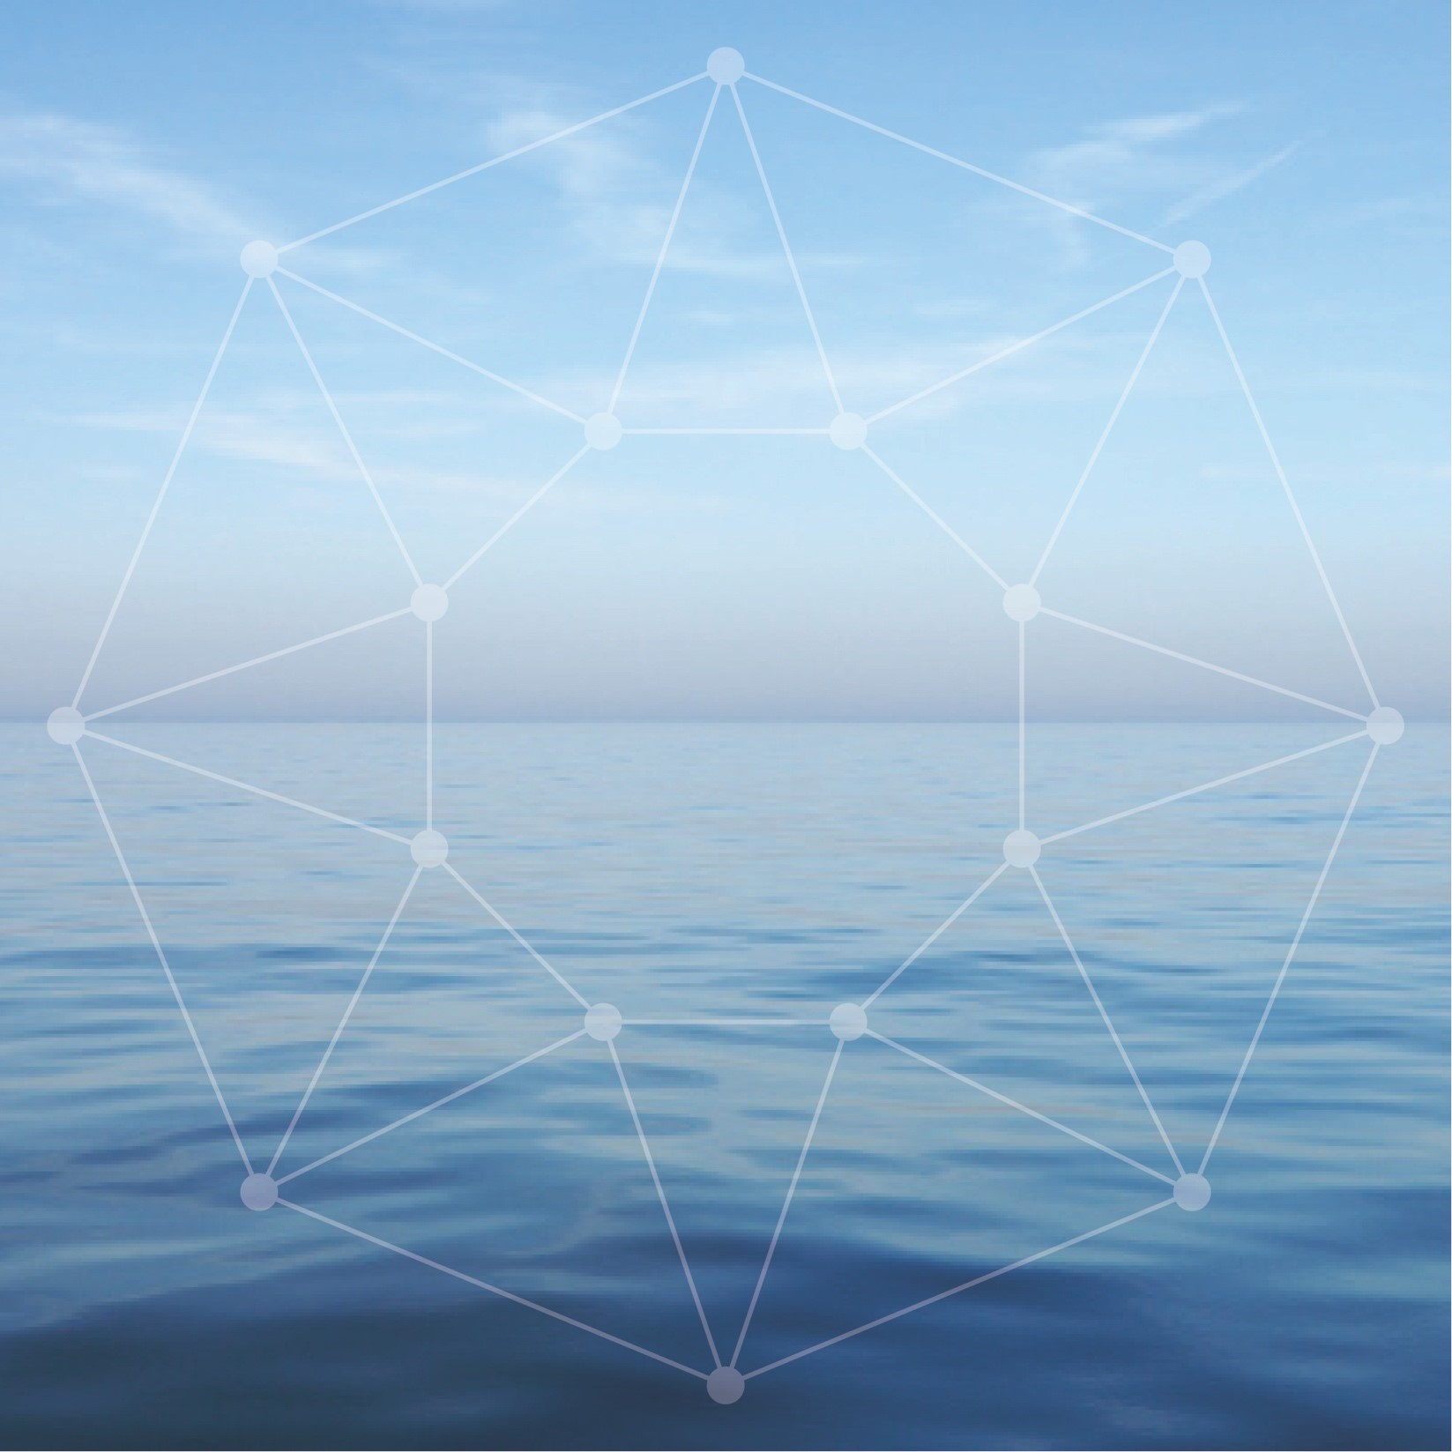

Location of Meetings: Meetings are usually held at the Commissioners of Irish Lights Headquarters at Harbour Road, Dun Laoghaire, Co Dublin, A96 H500. Meetings may take place at other locations from time to time. Remote attendance may be facilitated when necessary.

Number of Appointments
to be made: 4 Commissioners / Board members to be appointed.

Time Requirements: There are generally 7 Board meetings per annum which generally take place on a Friday lasting approximately 5 hours with a break for lunch. In addition, these may be supplemented and/or merged with a Board workshop. There are 3 standing Board sub-committees, Audit & Risk, Nominations, Remuneration. From time-to-time special purpose sub-committees are established which are time and task bound.

Board members normally participate in a short (3 day) ‘Working
Inspection’ every twelve to eighteen months.
The purpose of the Working Inspection is to review the ongoing
programme of capital investment on the coast and to review the
impact of future or agreed policies on navigation, marine safety and
property management.

Main Governing Legislation: Merchant Shipping Act 1894 applicable in the Republic of Ireland and UK Merchant Shipping Act 1995 for Northern Ireland.

Registered Charity: Irish Lights has a charitable exemption from the Revenue Commissioners (CHY no. 1979) and is registered with the Charities Regulatory Authority (No 20002794). Board Members must be able to meet the Trustee requirements of section 55 (1) of the Charities Act 2009 as amended by the Charities (Amendment) Act 2024 – note: Relevant amendments have yet to be commenced.

Funding & Governance: Irish Lights is funded via the General Lighthouse Fund (GLF) which is administered by the Department of Transport (UK). Irish Lights funding sources include light dues collected in Ireland, a GLF contribution of 15% for Northern Ireland, funds from commercial activities and a contribution from the Department of Transport (IRL). Irish Lights meets the reporting and compliance requirements of the Department of Transport for non-commercial state bodies in line with the Irish Code of Practise for State Bodies 2016 (as amended). Irish Lights also meets the governance requirements laid down by the Department for Transport (UK) for the General Lighthouse Fund.

Scale of Organisation: 126 employees and budget of circa €20m

Remuneration: Board members do not receive any fees for their services.

Background
Irish Lights is vested under Section 634 of the Merchant Shipping Act 1894 with the responsibility for superintendence and management of all lighthouses and other AtoN in respect of Ireland and the adjacent seas and islands. The Merchant Shipping Act 1995 Section 195 (1) empowers Irish Lights with the same function for Northern Ireland. Irish Lights also has responsibility for the marking and removal of wrecks in Ireland under the Merchant Shipping (Salvage and Wreck) Act 1993 Part IV and for Northern Ireland authority is vested in Irish Lights under the Merchant Shipping Act 1995.
Irish Lights is responsible for meeting the Irish and British Governments’ responsibilities under Chapter V Regulation 13 of the International Maritime Organization’s, Safety of Life at Sea (SOLAS) Convention.
The mission of Irish Lights is Safe Navigation at Sea. We are a maritime organisation delivering essential 24/7 safety and navigation services around the coast of Ireland (north and south), 365 days a year. Our vision is to protect lives, property, trade and the environment by delivering next generation maritime services at the interface of navigation technology, data and engineering.
Irish Lights is responsible for Maritime Aids to Navigation (AtoN) under the Safety of Life at Sea (SOLAS) Convention. This remit includes the provision and maintenance of over 330 general aids to navigation, the regulation and superintendence of approx. 3,500 local aids to navigation and marking or removing dangerous wrecks outside harbour areas around Ireland.
Irish Lights also provides a range of navigation and contract commercial services including ship charter, buoy services, equipment hosting and maritime data. Where appropriate and beneficial Irish Lights provides value added services to support the development of the broader maritime economy including Met and Coastal Data Services. The Irish Lights tourism and heritage initiative, the ‘Great Lighthouses of Ireland' has been developed in partnership with local communities to support lighthouse heritage preservation and sustainable local tourism (GLI_Strategic_Plan_2025-2030.pdf).

Strategic Direction
The current Irish Lights strategy for the period 2025-2030 “Safe Seas – Connected Coasts” was launched in April 2025. The strategy is available here and clearly sets out the Mission, Vision and Strategy for Irish Lights:
Mission
Safe Navigation at Sea – To be a leading provider of reliable, efficient and cost-effective navigation and maritime services for the safety of all.

Vision:
Irish Lights will be a dynamic, forward facing maritime organisation, conscious of our long history and poised to deliver future safe, smart and sustainable maritime services – at the interface of navigation, technology, data and engineering.
We will do this by:
- Contributing to the safe development of the maritime economy and climate resilience.
- Continuously upskilling our people and teams to deliver new capabilities in the maritime space.
- Protecting our heritage and legacy
As the provider of General Aids to Navigation around the island of Ireland (north and south), Irish Lights has a long and respected track record of service to the maritime community dating back to 1786. In more recent times, the context in which that service must be delivered has changed. This is due to rapid technological advances, pressures on the marine and coastal environment and more diverse stakeholder needs, requiring a greater emphasis on collaboration across agencies and with international organisations. This creates both opportunities and challenges, which are proactively addressed in our 5 year strategy. The strategy recognises the exciting and challenging trends in the maritime sector at national and international level. It places a strong emphasis on ensuring that Irish Lights can play a leadership role in the delivery of next generation navigation and safety services, enabled by innovation and technology.

Irish Lights Board
- Functions of the Board
The function of the Board is to decide on policy and strategy for the organisation and oversee its’ implementation, ensuring that high standards of governance are met.

While day to day responsibility for leadership and control is delegated, within defined authority limits, to the Chief Executive and the Management Team, the Board is ultimately accountable for the performance of the Commissioners of Irish Lights.

- Composition and Terms
The Board has due regard for the benefits of diversity, experience and expertise and strives to achieve the right balance in its goal to provide leadership, effectiveness, accountability and sustainability to Irish Lights.
The Board consists of:
- 11 Board Members/Commissioners.
- The Lord Mayor of the city of Dublin plus three Councillors’ of the City of Dublin (ex officio Commissioners).
- The Chief Executive in her capacity as Accounting Officer is a member of the Board with no voting rights.

Irish Lights considers all Commissioners to be non-executive, independent Directors. A Register of Interests that includes details of company directorships or other significant interests held by Board members is maintained and updated annually.

New Board members are appointed for a 5-year term with the possibility of a renewal for another 3 years. The Lord Mayor and ex officio members are appointed as Board members for as long as they hold such office.

- New Board Member - Person Specification

The Board of the Commissioners of Irish Lights invites expressions of interest from suitably qualified individuals to fill four positions.
Attention is drawn to the provisions of the Code of Practice for the Governance of State Bodies in relation to the role of a board member, where the principle states that non-executive board members should bring independent judgement to bear on issues of strategy, performance resources, key appointments and standard of conduct.
Details on the role of board members can be found in section 3 of the Code of Practice for the Governance of State Bodies which can be found here.
Essential
Profile 1 - Financial experience and expertise
Individuals wishing to apply for this vacancy must show evidence of financial experience. This individual must be a qualified accountant and have significant senior management experience. Ideally, the candidate will also have experience, interest and a willingness to serve on the Audit and Risk Committee.
Profile 2 - A legal professional
Individuals wishing to apply for this second vacancy must have a qualification and experience in the legal profession.
Profile 3 – Risk and Compliance

Individuals wishing to apply for the third vacancy must detail their professional qualifications and experience at an appropriately senior leadership level in one or more of the following areas: risk of compliance.

Profile 4 - Environmental, Sustainability, Heritage expertise

Individuals wishing to apply for the fourth vacancy must detail their professional qualifications or experience at an appropriately senior leadership level in one or more of the following areas: environment, sustainability or heritage expertise

Desirable
All applicants should outline any experience they have in the following areas:
- Public Sector Governance
- Marine, Maritime and Navigation. Here we are specifically looking for anyone with expertise or work experience in the maritime sector, such as shipping, ports, offshore wind, fisheries, leisure, marine technology and surveying. We are also looking for people with navigational knowledge, supported by a relevant qualification, sailing or seafaring background, including Leisure, Yacht Master, Merchant or Navy.

The Board encourages applications from qualified candidates from Ireland and Northern Ireland with due regard to gender balance, diversity and inclusion.
In order to qualify for appointment a person must not have any legal impediment or conflicts of interest likely to interfere with his/her ability to assume the role of Commissioner / Board member. Individuals should give careful consideration to the possibility of any potential conflict of interest that may exist and address this in their cover letter. The Selection Panel may decide, based on the perceived level of conflict, not to forward such individual for consideration.
In addition to the above, standard eligibility requirements for public office / charity trustee will apply.

- Term of Appointment
Appointment to the Board will be for a period of 5 years with the possibility of an extension of another term of 3 years. The roles and responsibilities of Board Members are described in the Code of Practice
for the Governance of State Bodies 2016.

The office of a Commissioner / Board Member shall be vacated in any of the following events, namely: -
- If he/she resigns the office by notice in writing to the Chairperson of the “Board”.
- If he/she becomes bankrupt or makes any arrangement or composition with his creditors generally.
- If he/she by an act of omission has been convicted of a criminal offence, excluding minor offences.
- If he/she in the opinion of the Board becomes incapable by reason of illness of discharging the duties of a Commissioner/ Board Member.
- If he/she in the opinion of the Board, has been guilty of any misconduct, or has deliberately failed to discharge the duties of a Board Member, or has so conducted himself/herself that his/her continued presence on the “Board” could have a detrimental effect on the efficiency or reputation of the “Commissioners of Irish Lights.”
- If he/she has been absent from meetings of the “Board” for more than three consecutive meetings unless he/she has received a licence for absence or in the opinion of the “Board” has shown reasonable cause for his/her absence.
- The membership of any member of the Board may be terminated by the Chairman at any time, on the basis of reasons to be stated by the Chairman.

- Submitting your Expression of Interest
All applicants must complete the Expression of Interest Form in Appendix 1. Applicants should consider carefully how their background and experience meets the specific appointment criteria detailed in the previous section.

- Assessment Process
To apply, please complete an Expression of Interest form and return it by email with a curriculum vitae, cover letter and any supplementary information you wish to add to Boardappointments@irishlights.ie on or before the 29th April 2026.

A Selection Panel (the “Panel”) will be convened by the Nominations Committee to consider and assess the expressions of interest received by Irish Lights. The Panel will:

- Review and discuss the expressions of interest received against the specific appointment criteria for the role, as advertised in this Information Booklet;

- Assess potential candidates further once they meet the specified appointment criteria by undertaking any or all of the following steps:
  - Consideration of the written applications; and/or
  - Interview; and/or
  - Referee checks; and/or
  - Any other selection or verification method deemed appropriate.

- Shortlist candidates will be contacted the week beginning the 4th May 2026.

- Interviews, as appropriate, will take place in May 2026 in the Irish Lights Head Office in Dun Laoghaire.

- The Nominations Committee on the advice of the Selection Panel will make a recommendation to the Board for their approval.

- Following approval from the Board, the approval of the Department of An Taoiseach will be sought.

- The process is expected to conclude by the end of July 2026.

- Confidentiality

Applications will be treated in the strictest confidence. All enquires, applications and all aspects of the proceedings are treated as strictly confidential and are not disclosed to anyone, outside of those directly involved in that aspect of the process.

- Data Protection
Irish Lights will process all expressions of interest in accordance with applicable data protection legislation, including the principles of fairness, transparency, and purpose limitation. Personal data provided as part of the expression of interest will be used solely for the purpose of assessing suitability for the role and will be handled securely, accessed only by authorised personnel involved in the selection process. All information will be managed in line with Irish Lights Data Protection Policy.
APPENDIX 1
Expression of Interest Form
NOTICE OF CANDIDATURE FOR APPOINTMENT TO BOARD OF IRISH LIGHTS
Name:
Address:

Email address:
Mobile number:

Position Applied for:

Educational and Professional Qualifications:
Details of Board / Management Experience (please specify):
Details of Marine / Maritime / Navigation experience or interest in Marine Sector:
Details of Public Sector Governance experience

Details of qualifications and or capability in one or more of the following fields:

- Financial experience and expertise – a qualified accountant ideally with Audit and Risk Committee interest and experience.
- Qualification and experience in the legal profession.
- Professional qualification and experience of risk or compliance.
- Professional qualification and/or experience in the areas of environment, sustainability or heritage.
Other experience which could benefit Commissioners of Irish Lights:
I wish to be considered for appointment to the Board of Commissioners of Irish Lights:

Signed:
Date:

Please submit any queries or questions by email to boardappointments@irishlights.ie.
Please submit your curriculum vitae, cover letter and any other supplementary information with the completed Expression of Interest form to Boardappointments@irishlights.ie by
29th April 2026

Privacy Notice

By submitting this application to Irish Lights you are consenting to the provision of your personal data for use by Irish Lights. The data you provide will be used by authorised personnel for the purposes of Board Selection only. The legal basis for processing this data under Data Protection Legislation is Consent.

The data you provide will be held in accordance with the Irish Lights Retention & Disposal Policy and will be destroyed 3 months after this process closes. Irish Lights will not use your personal data for direct marketing purposes and your data will not be subject to profiling or automated decision making. This data will not be shared with an external third party.

For more information please refer to the Irish Lights Privacy Statement on our website http://www.irishlights.ie/terms.aspx#dataprotection or contact the Data Protection Officer at DPO@irishlights.ie

